Vanessa Diazdeleon
Music 512
Dr. Payne
2 November 2018
Assessment Portfolio

- Pencil and Paper Test
  - Definition: A written exam used to gather cognitive data of learners.
  - This assessment tool may be used to assess terminology historical elements, basic music theory concepts, etc.
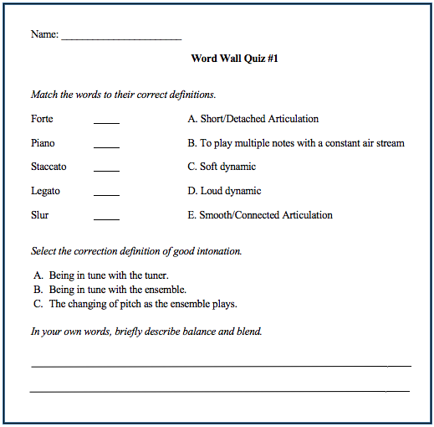

Validity and Reliability Plan:
- Make exam dates known to students in advanced and maintain a consistent “Test Day” routine.
- Provide students with a study guide or description of the content on the quiz.
- Grade from an answer key, determine if short answer questions are norm-referenced or criterion-referenced and remain consistent.

Adjustments:
- Utilize different ratios of selected and created responses as well as various types of each.
  - Ex.) fill in the blank, multiple choice, matching, short answer, essay.

- Checklist
  - Definition: A tool used to record cognitive and psychomotor data of learners following an observation.
  - This assessment tool may be used to check for the presence of specific musical elements in large groups of learners.
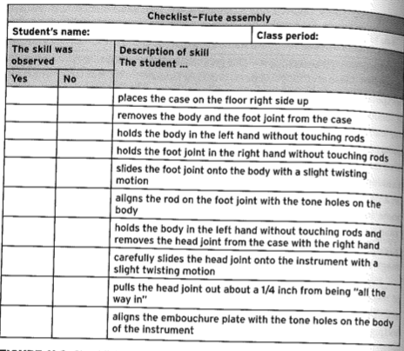
Validity and Reliability Plan:
- Create clear, black and white, descriptions of skills.
- If unclear about how a student is performing, ask them to verbalize or explain their thought process/actions.

Adjustments:
- Checklists can be used by students in peer-assessments as well, this allows teachers to review the quality of feedback students give each other.
- Have students submit a video recording of themselves completing the selected task for closer assessment later on.
- Video recordings also require students to self-asses their skills and select the best recording for submission.

- Rating Scale
  - Definition: A tool used to record criterion-referenced cognitive and psychomotor data of learners, and to provide specific feedback following an observation.
  - This assessment tool may be used to check for the presence of specific musical elements, the level of its development, and to provide feedback to learners.
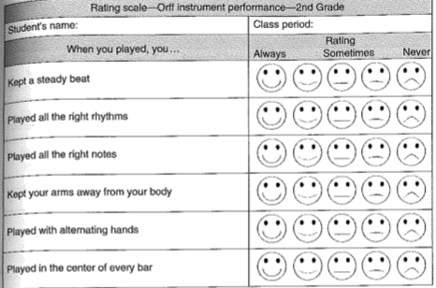Validity and Reliability Plan:
- Consider recording lessons when utilizing a rating scale to review student’s individual performance more closely.
- Consider using concise percentages or time ratios in place of ambiguous terms such as “always, sometimes, never.”

Adjustments:
- Rating scales can be given to individuals to assess their own performance.
- Rating scales can be utilized in peer-review, quality of student feedback to each other can also be assessed.

- Rubric
  - Definition: A set of scoring criteria used to measure achievement levels of a learners cognitive and psychomotor data.
  - This assessment tool may be used to bring awareness to educators (and learners) of the learner’s current performance level compared to the described performance levels.
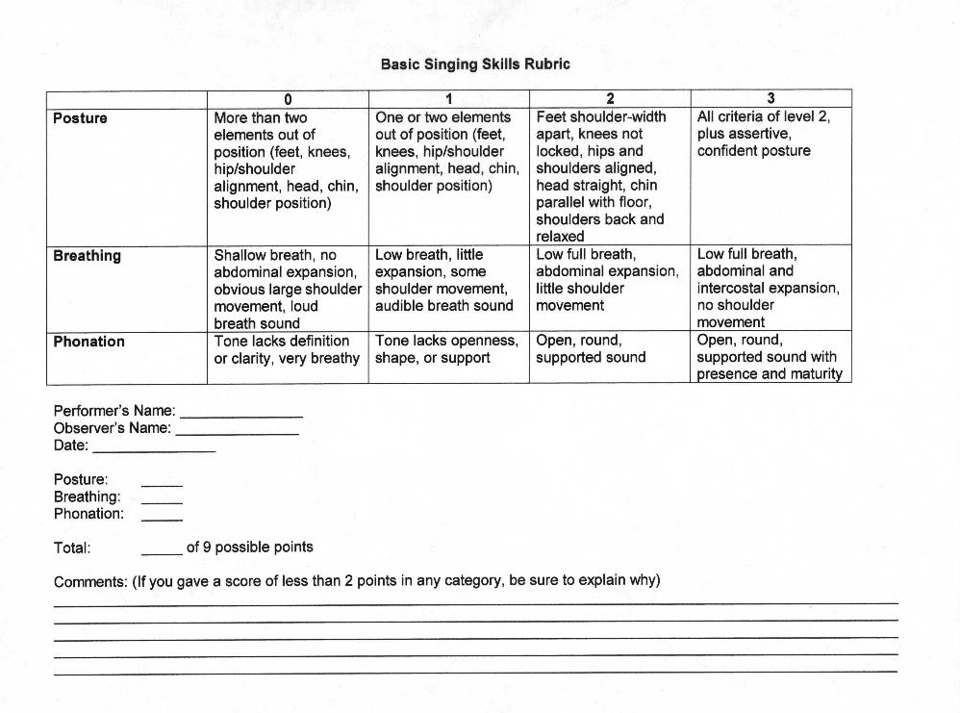
Validity and Reliability Plan:
- Clearly describe each level of achievement per assessed criteria and grant student access to rubric in advanced.
- Maintain similar requirements for each point level from rubric to rubric.

Adjustments:
- Differentiated rubrics can be utilized to scaffold student progress to teacher expectations.

- Portfolios
  - Definition: Collected documents of learner achievement in cognitive, psychomotor, and affective data.
  - This assessment tool may be used to collect student-selected content, requiring the learner to assess the quality of their own work as well.
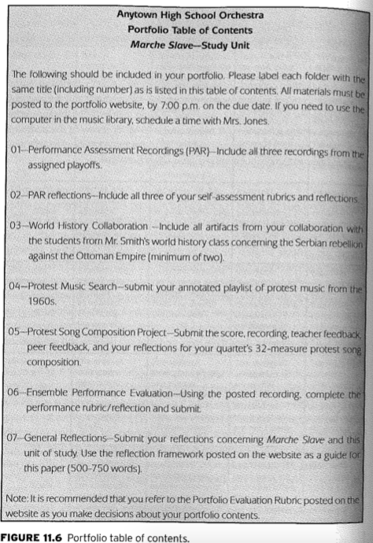
Validity and Reliability Plan: (Linn and Miller’s Five “Key Steps” for Creating and Using Portfolios as a general guide (2005).
- Specify the purpose of portfolios to students.
- Provide guidelines for selecting portfolio entries.
- Define student role in selection and self-evaluation.
- Specify evaluation criteria.
- Use portfolios in selection and self-evaluation.

Adjustments:
- Portfolios are extremely flexible and adjustable assessment tools as students can select any representation of their best work. Ex.) Video recordings, essays, test grades, awards, etc.

- Journaling
  - Definition: Prompted, Open-ended, written thought used to collect the product of learner cognitive, psychomotor, and affective data over time.
  - This assessment tool may be used to encourage learner reflection of musical experiences, to build community through student prompt exchange-and-responds, and to provide individualized instruction.

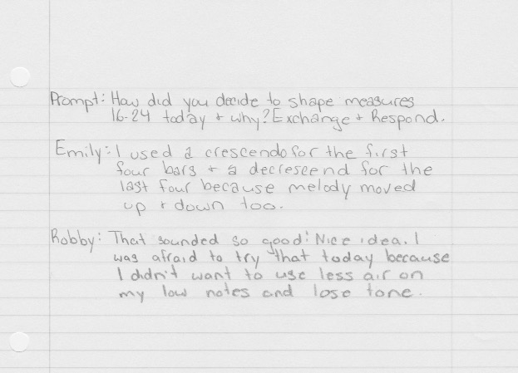
Validity and Reliability Plan:
- Provide feedback to students in a timely fashion.
- Reserve a spot in journals for students to write goals.
- Ask students to occasionally share with peers but also allow them to share with just the teacher.

Adjustments:
- Different prompt types can be used to access multiple aspects of information about learner comprehension.

- Oral Summary
  - Definition: A measurement of learning outcomes (cognitive, psychomotor, affective) by questioning students and recording their verbal responses.
  - This assessment tool may be used as alternative to a pencil and paper test or journal entry in music to provide students the opportunity to share their learning entry immediately and with no outside influence.

https://www.youtube.com/watch?v=P-dm9Z6GR9s&feature=youtu.be

Validity and Reliability Plan:
- Use a combination of probing, prompting, and challenging questions (utilize the levels of blooms taxonomy).
- Allow sufficient time for student responses.
- Prepare a structured marking sheet for assessors.

Adjustment:
- Students can answer questions or share daily take-aways with the teacher as well as with partners in class.

- Performance
  - Definition: A form of immediate assessment of learner skills (cognitive, psychomotor, affective) by demonstration.
  - This assessment tool may be used in music in the form of a playing test or contest participation.

https://www.youtube.com/watch?v=GpgiqSMVmQo

Validity and Reliability Plan:
- Prepare a structured marking sheet for assessors.
- Model the expectation for students before their assessment time.
Adjustment:
- Students submit a video recording of their performance, incorporating self-assessment and selection of their best sample.

Source Dump:
Raiber Assessment Article
http://portfolio.reecezone.net/artifact3.htm

